Olmsted County Adult Mental Health Local Advisory Council  On-Site Location: Family Service Rochester  4600 18th Ave NW, Rochester, MN 55901  Date: Thursday, March 12th, 2026  Time: 12:30 – 2:00 PM  Teams Link: https://teams.live.com/free  (Click on the ‘Join a Meeting’ icon and enter Meeting ID and Meeting passcode)  Meeting ID: 218 504 257 429  Passcode: Kn9DR3MT  Or Dial in by Phone:  Phone Number: (507) 218-8528  Phone conference ID: 422 193 293#  AGENDA  12:30-12:50 PM: Welcome & Introductions Lindsey Hickey  12:50-1:10 PM: Meeting Expectations Lindsey Hickey  1:10-1:20 PM: Group Updates LAC Council  1:20-1:40 PM: Vail Comm. Listening Sessions Laura Sutherland  1:40-2:00 PM: Presentation and Survey Lindsey Hickey  Committee Update  Next Meeting: April 9th, 2026 | 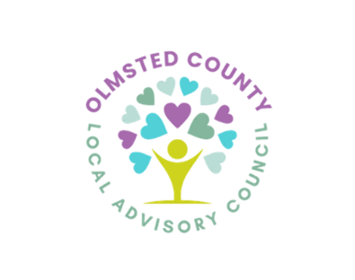  LAC Members  Tricia Carlstrom  Samuel Case  Angie Ellsworth  Miriam Fei  Janie Holliday  Carrie Johnson  Toni Mangskau  Ethan McConkey  Tammy Rider  Bri Rollins  Karissa Wilson  Executive Committee  Lindsey Hickey (Co-Chair)  Megan Toney (Co-Chair)  Monica Yeadon (Secretary)  Janessa Winters (Member-At-Large)  Talor Gray (County Liaison)  Laura Sutherland (County Liaison)  Mission and Values:  The LAC brings together diverse perspectives on mental health in order to identify resources, changes, additions, and improvements to local mental health services for adults.  Values informing the work include:  Hope. The sense that positive change is possible and needed should be the foundation of our work.  Prevention. Mindful nurturing of individuals’ well-being and trauma sensitivity will improve their mental health throughout their lives.  Wisdom. Each person’s wisdom has value and requires consideration.  Recovery. Achieving a state of recovery for each person who needs mental health support is vital.  Dignity. Dignity is essential to our work together so each person can deserve and expect to be treated with respect and honor.  Inclusivity. Inclusion is critical to ensure that our mental health services and perspectives are relevant, inclusive, and responsive to the many ways our county is diverse.

