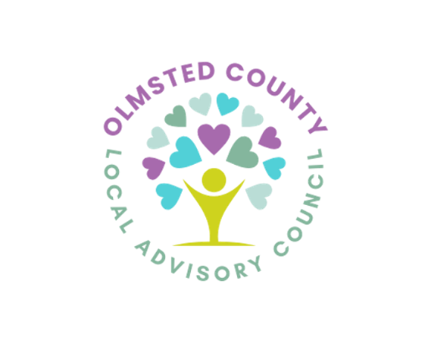
050Olmsted County Adult Mental Health Advisory Council

On-Site Location: Family Service Rochester
4600 18th Ave NW Rochester, MN

Teams Link: https://teams.live.com/free (click on the ‘Join a Meeting’ icon and enter Meeting ID and Meeting passcode)
Meeting ID: 218 504 257 429
Passcode: Kn9DR3MT

Or Dial in by Phone:
Phone Number: (507) 218-8528
Phone conference ID: 422 193 293#

Date: Thursday January 8th, 2026
Time: 12:30 – 2:00 pm
Facilitators: Co Chairs, Lindsey Hickey and Megan Toney
Executive Committee Members: Monica Yeadon (Secretary), Talor Gray (County Liaison), and Laura Sutherland (County Liaison)
Invitees: LAC Members and Public

AGENDA

12:30-12:50 PM: Introductions and Updates Lindsey Hickey &
Executive Committee

12:50-1:10 PM: Clubhouse International Outreach Update Laura Sutherland

1:10-1:50 PM: Executive Committee Report on Unmet Needs Janessa Winters
Assessment Data

1:50-2:00 PM: Meeting Closing All Members

Next Meeting: February 12th, 2026
(Please see Backside)

Mission and Values:
The LAC brings together diverse perspectives on mental health in order to identify resources, changes, additions, and improvements to local mental health services for adults.
Values informing the work include:
Hope. The sense that positive change is possible and needed should be the foundation of our work.
Prevention. Mindful nurturing of individuals’ well-being and trauma sensitivity will improve their mental health throughout their lives.
Wisdom. Each person’s wisdom has value and requires consideration.
Recovery. Achieving a state of recovery for each person who needs mental health support is vital.
Dignity. Dignity is essential to our work together so each person can deserve and expect to be treated with respect and honor.
Inclusivity. Inclusion is critical to ensure that our mental health services and perspectives are relevant, inclusive, and responsive to the many ways our county is diverse.

